Experiment 9:
Aim:
Write a Pandas program to create a Pivot table and find the total sale amount region
wise, manager wise, sales man wise.
Python code:
import pandas as pd

# Sample Data
data = {
"Region": ["East", "East", "West", "West", "North", "South", "North", "South"],
"Manager": ["John", "John", "David", "David", "Sara", "Mike", "Sara", "Mike"],
"Salesman": ["A", "B", "C", "D", "E", "F", "G", "H"],
"Sale_Amount": [5000, 7000, 8000, 6000, 9000, 4000, 3000, 7500]
}

df = pd.DataFrame(data)

print("Original DataFrame:")
print(df)

# Pivot Table
pivot = pd.pivot_table(
df,
values="Sale_Amount",
index=["Region", "Manager", "Salesman"],
aggfunc="sum"
)

print("\nPivot Table (Total Sale Amount):")
print(pivot)
output:
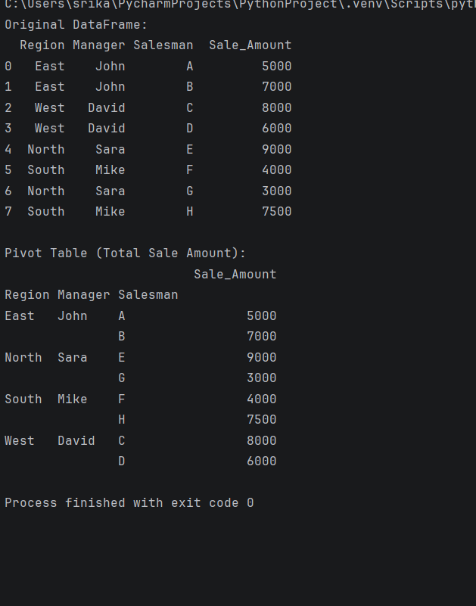
10.Create a dataframe of ten rows, four columns with random values. Write a Pandas
program to highlight the negative numbers red and positive numbers black.
Python code:
import pandas as pd
import numpy as np

# Create DataFrame (10 rows × 4 columns)
np.random.seed(10)
df = pd.DataFrame(
np.random.randint(-100, 101, size=(10, 4)),
columns=["A", "B", "C", "D"]
)

print("Original DataFrame:")
print(df)

# Function to color numbers
def color_negative_red(value):
color = "red" if value < 0 else "black"
return f"color: {color}"

# Apply styling
styled_df = df.style.applymap(color_negative_red)

# Display in Jupyter Notebook/Google Colab
styled_df
output:
Original DataFrame:

A B C D
0 -91 25 -85 -36
1 13 23 56 57
2 13 -92 -27 -100
3 -60 64 15 -84
4 0 39 -46 -12
5 7 22 -38 -67
6 100 0 77 79
7 -46 -23 97 -87
8 53 26 41 -8
9 -14 -70 58 -11

